Plotting Straight Line Graphs-Questions
Key Stage 3: 2003 Paper 1 Level 4-6
1.
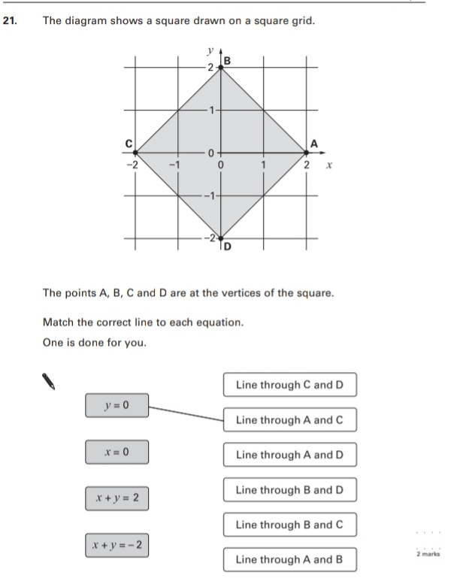
Key Stage 3: 2004 Paper 2 Level 4-6
2.
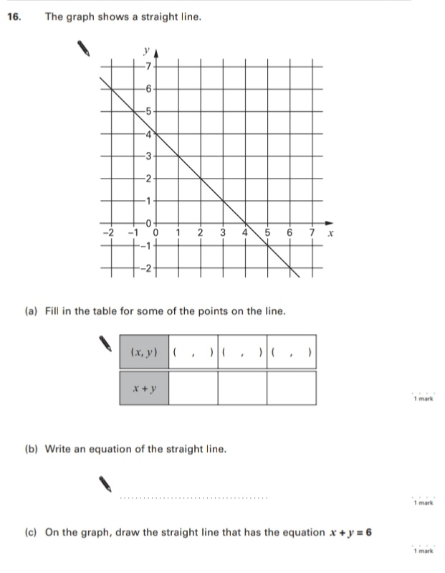
Key Stage 3: 2005 Paper 1 Level 4-6
3.
